CSC 133 Test Cases

Test Case 1: Launching the game

2. Precondition

2.1 – A1Prj.jar in dist folder

2.2 RunAssignment.jar is in the main A1Prj directory

3. Input:

Java -jar RunAssignment.jar A1Prj.jar

4. Output:

GUI/text fields

Title of software displayed in title bar

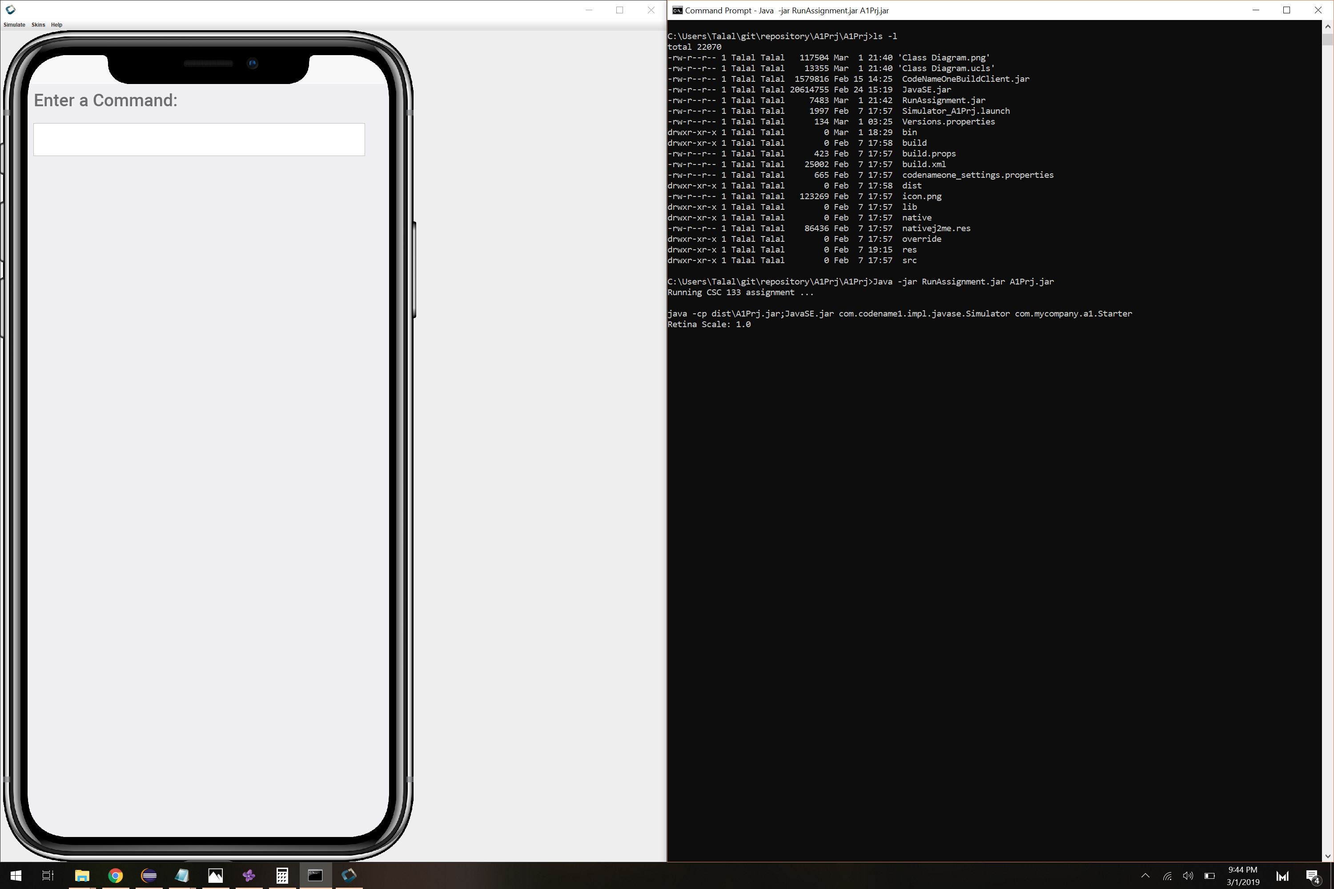

Test Case 2: Adding Object into Game

2. Precondition

2.1 : test case 1 successful

3. Input

a – asteroids

y - non player ship

s – player ship

4. Output

Verify objects are created by pressing p and m, which displays current game state values and game map.

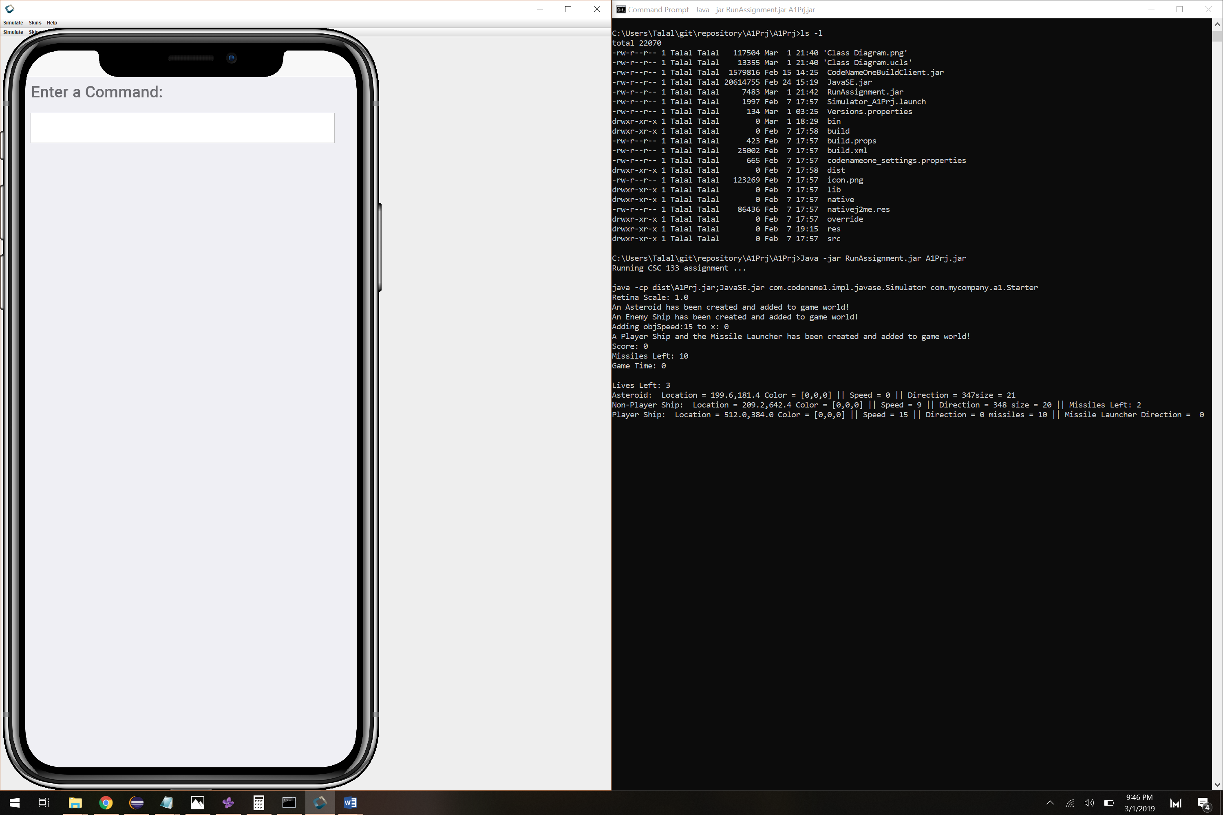

Test case 3: Quitting game

2. Precondition

2.1: test case 1 successful

3. Input

q – quit

4. Output

Game is no longer in computer memory

Q was pressed and CodeName1 instantly exited as expected. 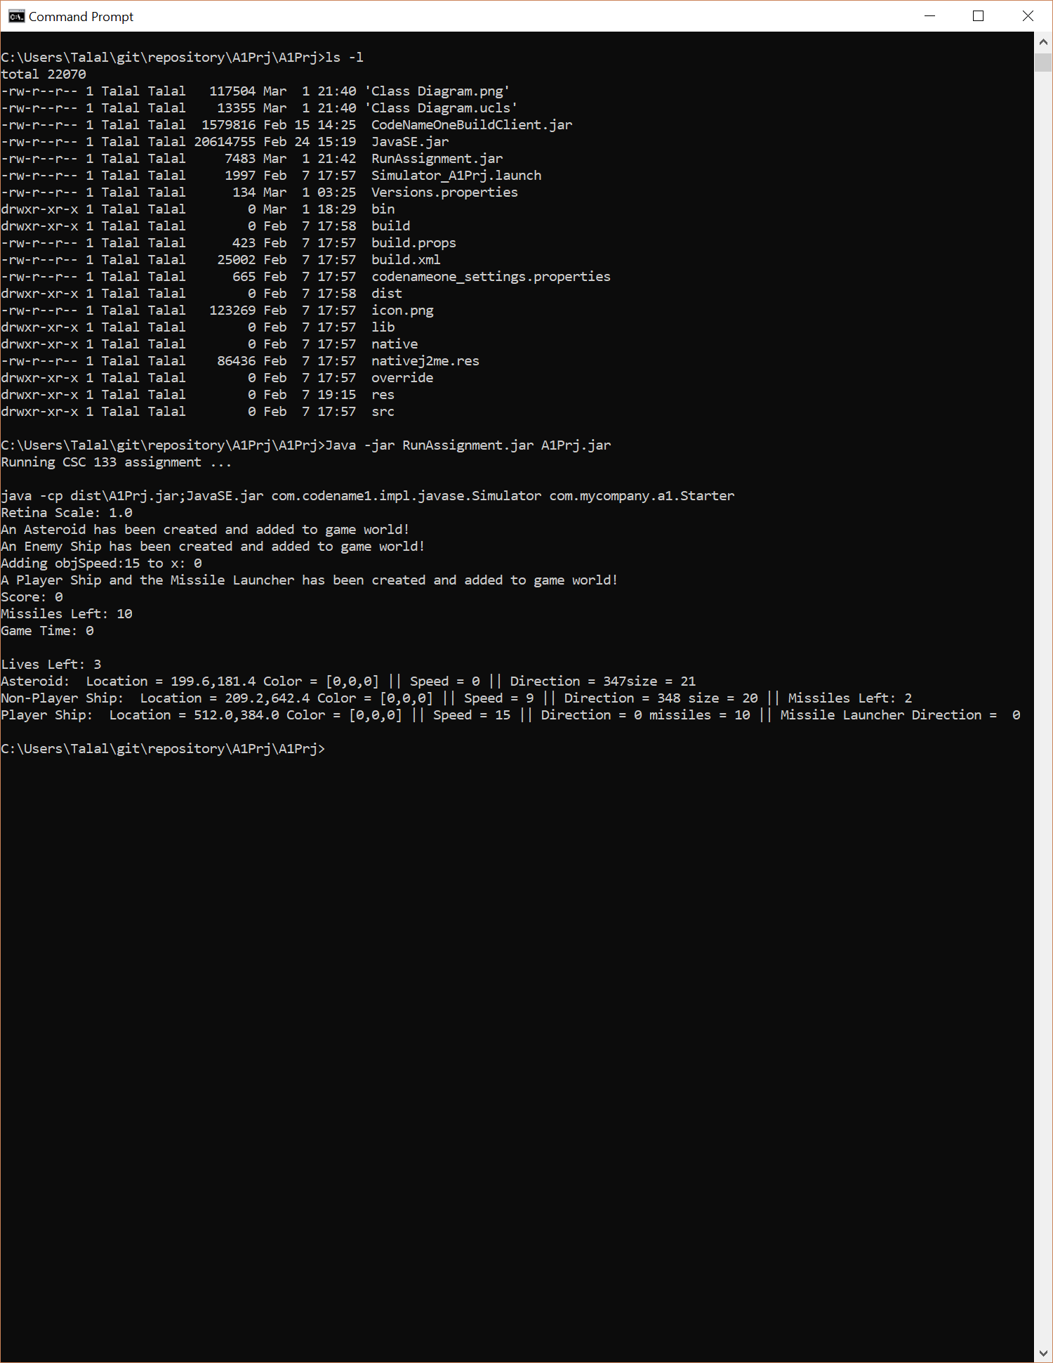

Test case 4: Removing object

2. Precondition

2.1: test case 1 successful

2.2 test case 2 successful – objects added

3. Input

c – game world removes ship and asteroid

h – game world removes NPS and PS

x – game world removes two asteroids from game

I – game world removes NPS and asteroid

Etc.

4. Output

Verify objects have been removed by pressing p, which displays game state values.

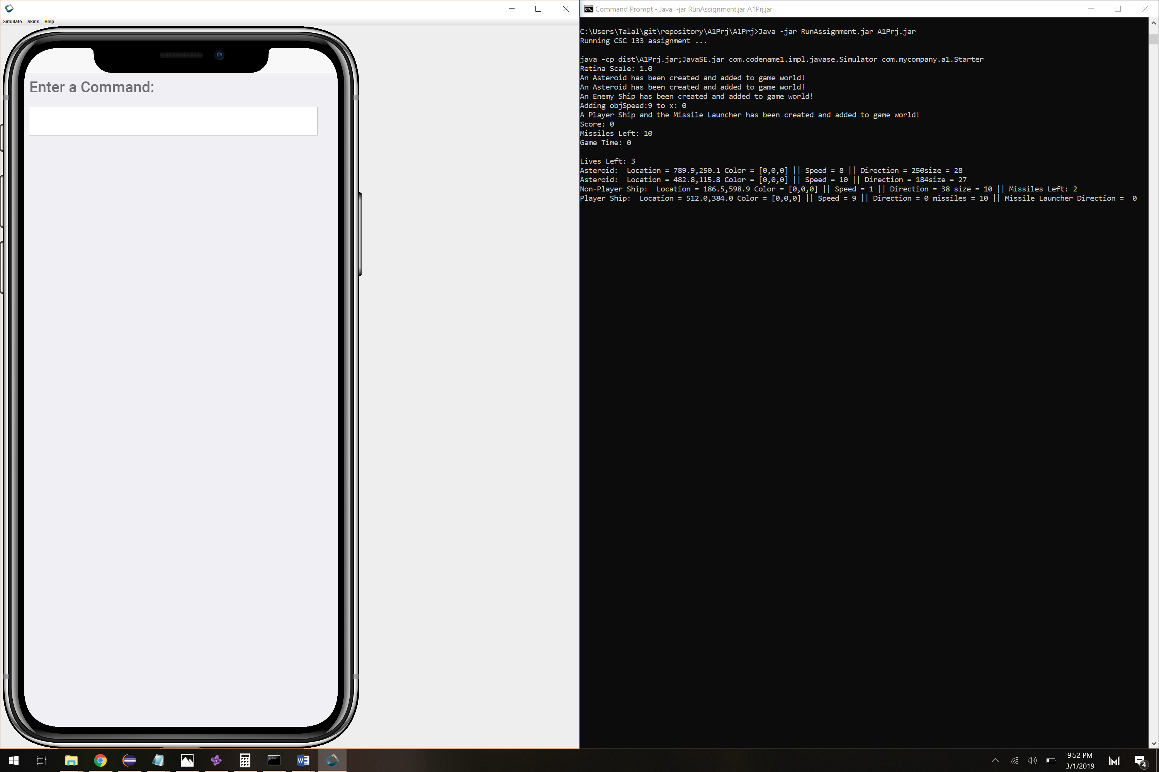

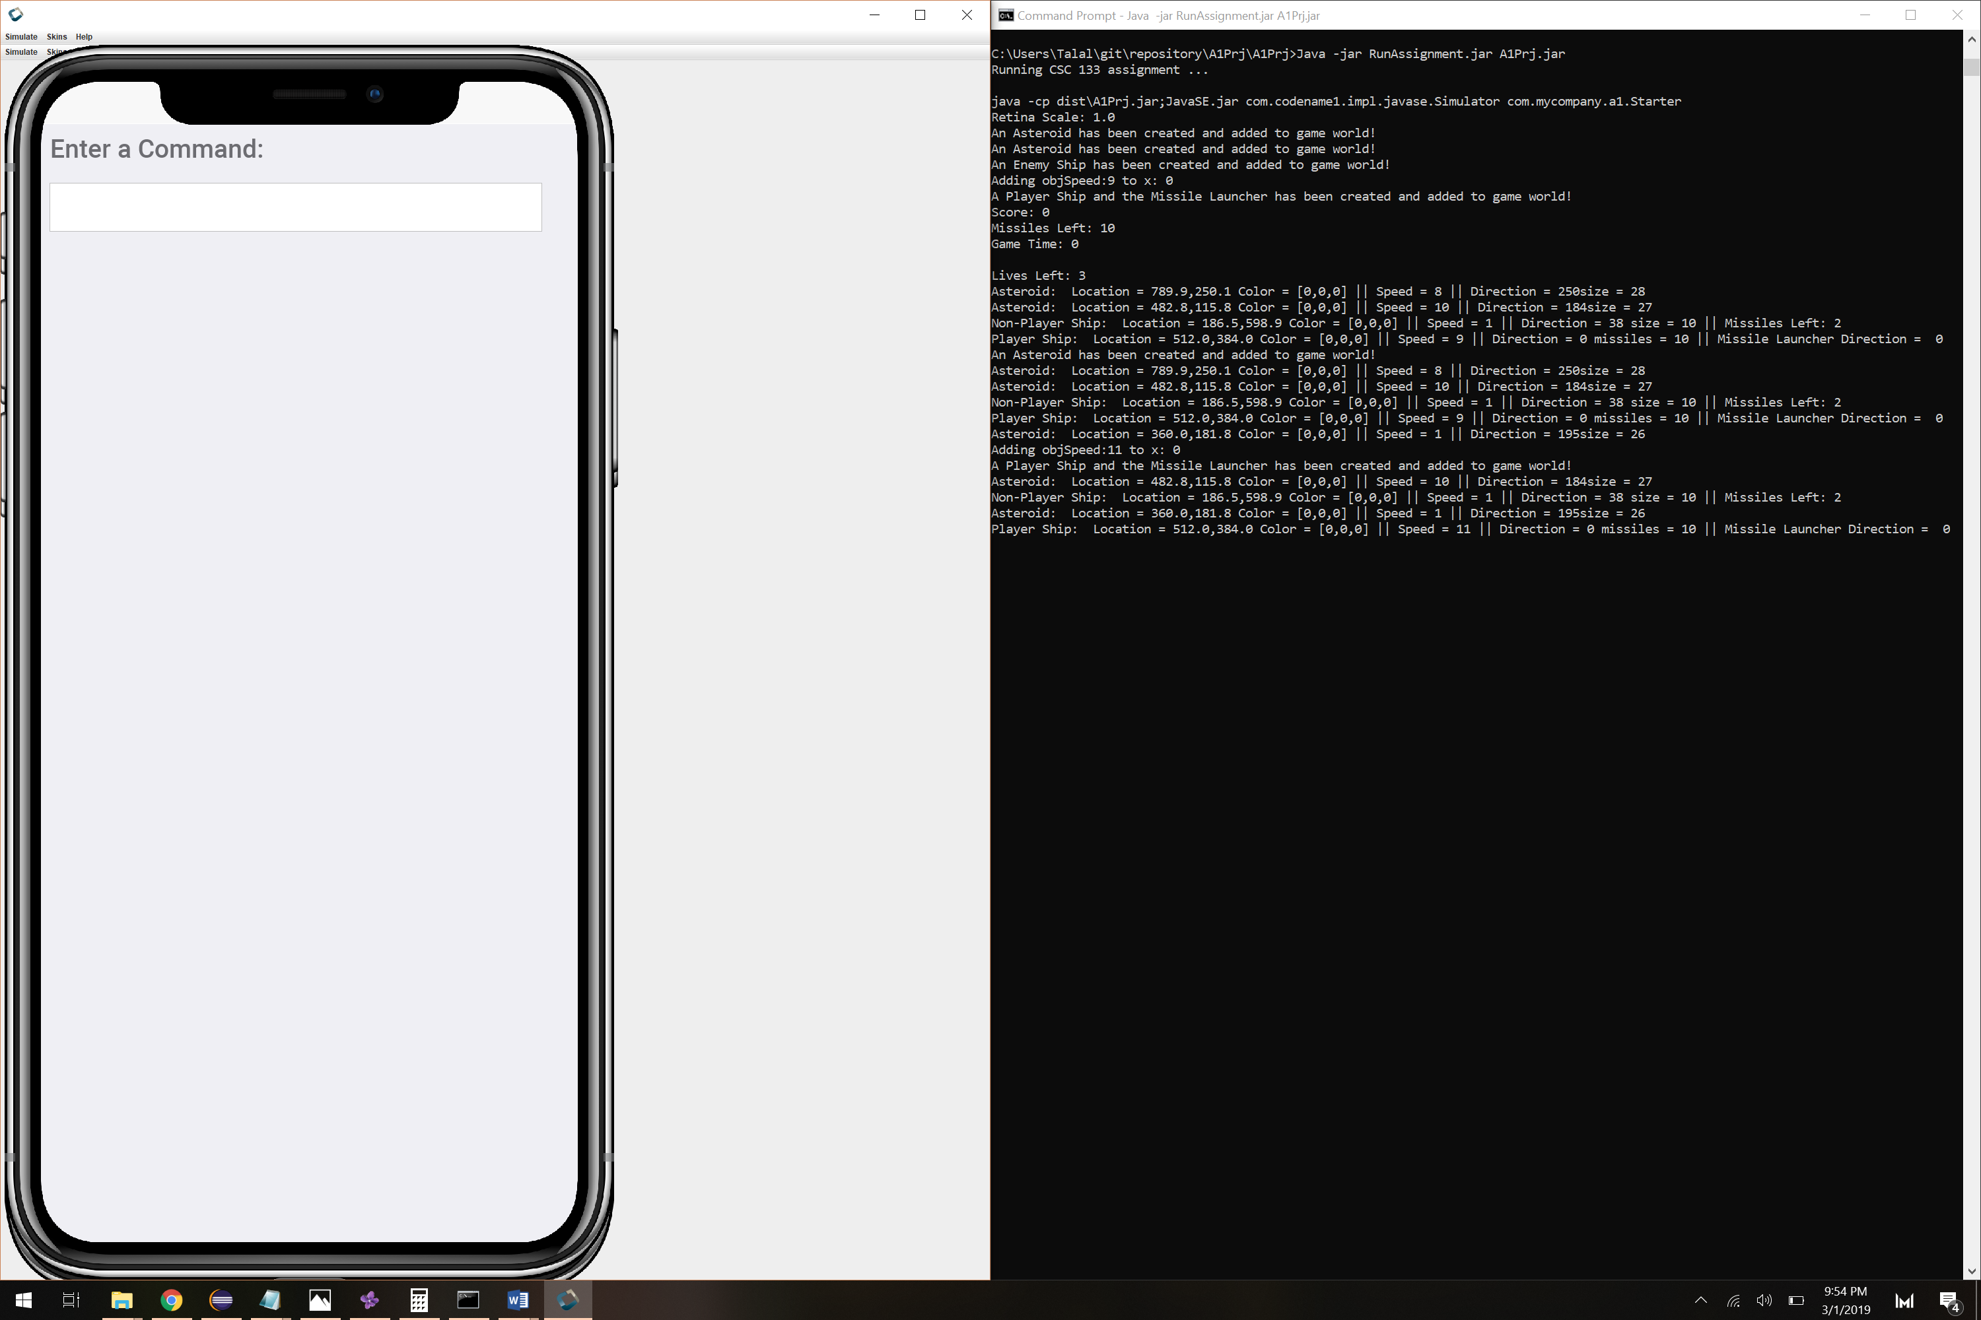

Pressing C resulted in asteroid and player ship being removed. Playership was then recreated as number of lives are still left as 2.

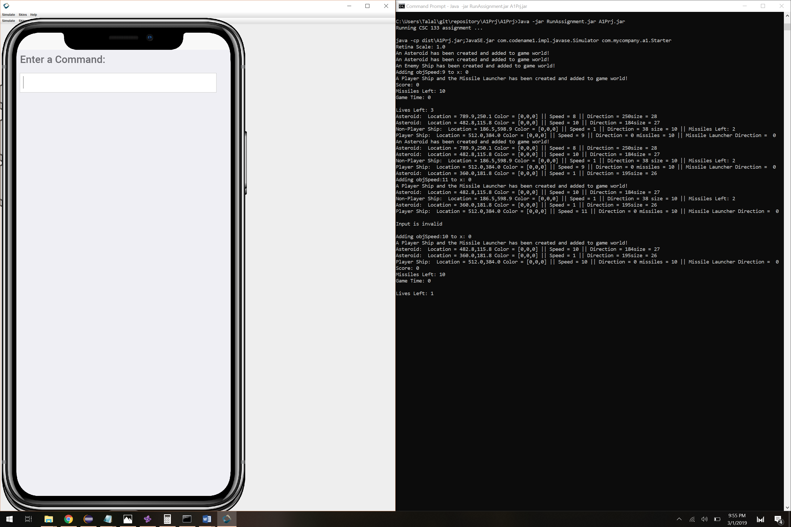Pressing h resulted in removal of NPS and PS, but PS was recreated as we had two lives. Now one life remains

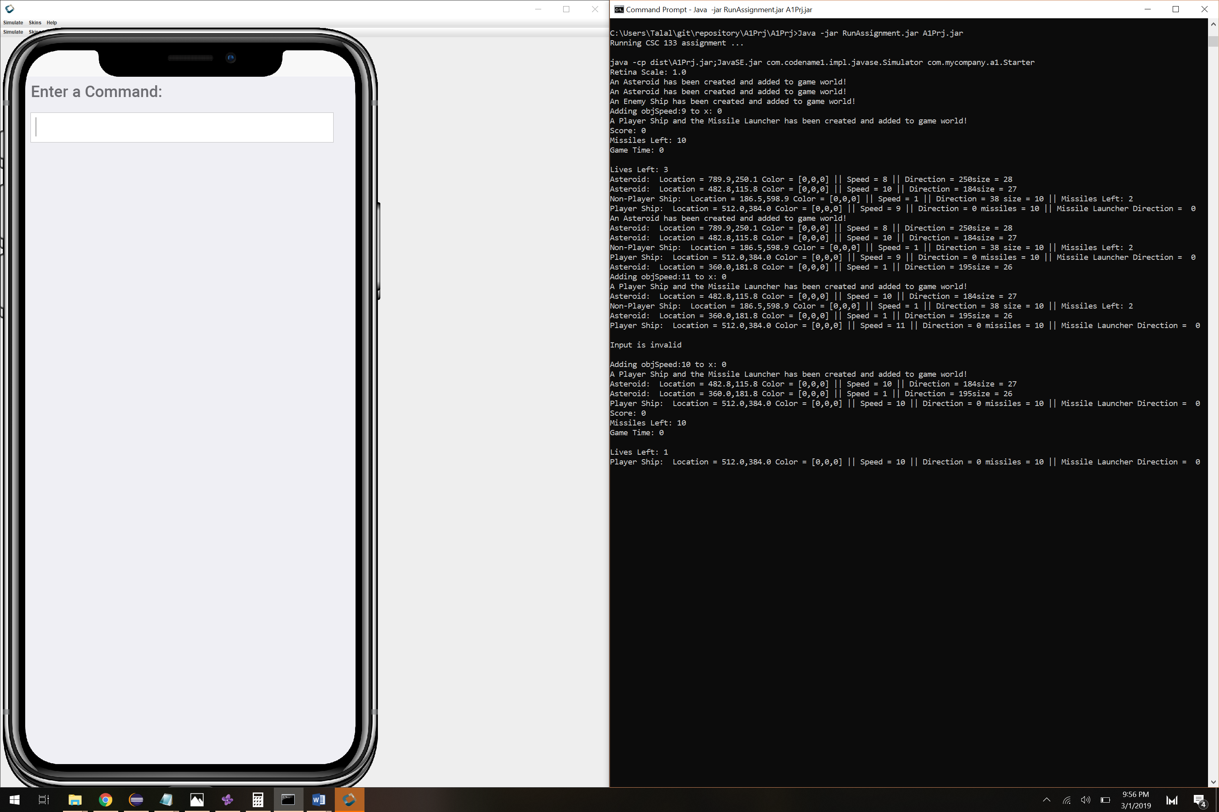

Pressing x resulted in removal of two asteroids as expected.

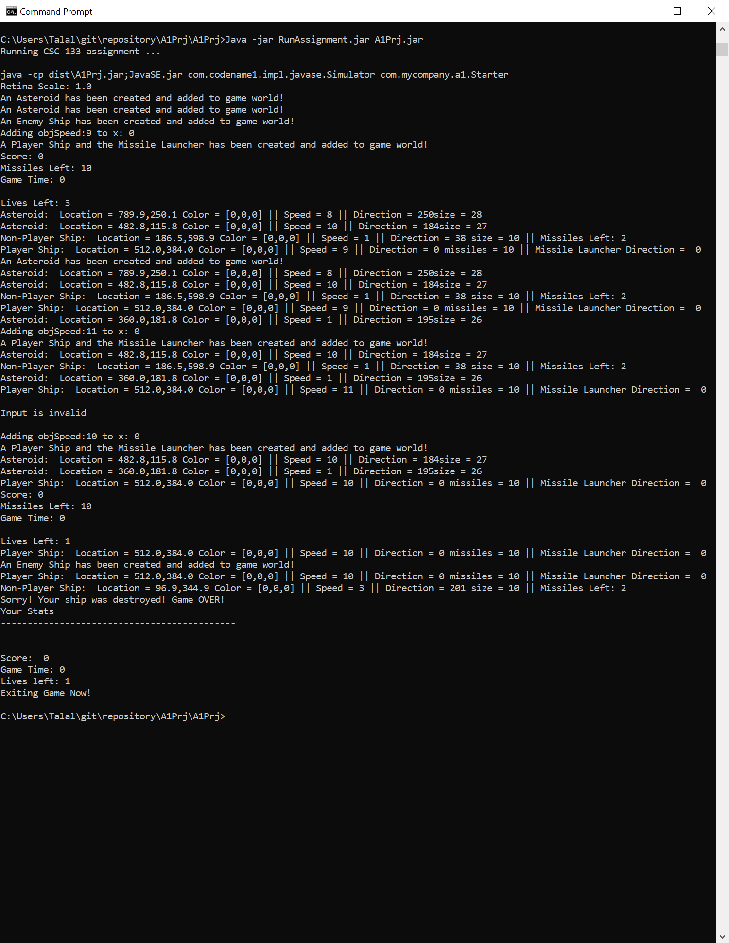

Pressing h after creating one NPS resulted in NPS and PS crashing into each other. This destroyed PS with no remaining lives, upon which the game instantly exited.